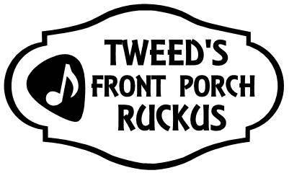

**Saturday June 28, 2025 1-4 pm**

**Family-friendly, free music at porches/venues throughout the village!**

**Signup form**

The Front Porch Ruckus is run entirely by volunteers – organizers, the musicians and porches! If you would like to participate by performing and/or hosting on your porch or stage, please fill out this form to provide us with some essential details, and email it to [tweedruckus@gmail.com](mailto:tweedruckus@gmail.com) . *It would be greatly appreciated if you signup as soon as possible, but the registration period closes on Sat. June 7.*

* Performers don’t need a porch to sign up…we can link you up!
* Porch hosts don’t need to provide performers…we can connect you!
* If you have both a porch and performer(s) to offer… we can accommodate that too!
* A ‘porch’ can be just that…or an indoor/outdoor stage, front lawns, driveways, backyards accessible from an alleyway etc.

This application is for:

* A. Porch Only (I need to be linked to a performer) 🞏
* B. Musicians Only (We need to be linked to a porch) 🞏
* A. & B. Both Musician(s) and a Porch 🞏

1. **Porch Host Info:**

|  |  |
| --- | --- |
| Name |  |
| Street Address (& Building Name if Applicable) |  |
| Phone |  |
| Email |  |
| Does Your Porch have an Electrical Supply Available? Would extension cords be needed? |  |
| Any Special Requests? (e.g., type of music, # of performers that can fit on your porch) |  |
| Have You Previously Participated in Tweed’s Front Porch Ruckus? |  |

**Page 1 of 2**

1. **Musician Info:**

* Unless otherwise arranged, you need to be willing to perform from 1 to 4 pm (with breaks)
* You are responsible for bringing your own PA etc.
* Please include a pic/image or two if possible with your application (for promotion purposes)

|  |  |
| --- | --- |
| Name of Key Contact Person |  |
| Name of Group/Band |  |
| Phone |  |
| Email |  |
| # of Performers (e.g., solo act, band of 3 etc.) |  |
| A couple of sentences describing your act (e.g., type of music) |  |
| Do you have any specific needs for your porch? (e.g., Electrical Supply?) |  |
| Pic/Image Provided (Yes/No) |  |
| Website/Social media (e.g., Facebook, Instagram, YouTube) |  |
| Would you be willing to be considered for participating in a possible ‘after party? |  |
| Have You Previously Participated in Tweed’s Front Porch Ruckus? |  |

Is there anything else we need to know? E.g., if you have more than one performer/group for your porch – please provide their information as per ‘B’ above

You will receive a confirmation email and/or call once your application is received! And periodic updates closer to June 28!

**Contact Us/Learn More:**

613-979-6400

[tweedruckus@gmail.com](mailto:tweedruckus@gmail.com)

[www.tweedartscouncil.ca](https://tweedartscouncil.ca/event/tweed-music-festivals-inc-front-porch-ruckus/)

@tweedsfrontporchruckus

**Page 2 of 2**